**612/2/3&5 Inst.Sch.**

**INSTRUCTIONS**

**FOR IPS**

**Paper 2,3 and 5**

**Jul/Aug 2016**

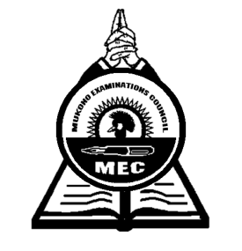

**MUKONO EXAMINATIONS COUNCIL**

**Uganda Certificate of Education**

**IPS CONFIDENTIALS**

**Paper 2, 3 & 5**

**Note:**

*Great care should be taken that the information given below does not reach the candidates either directly or indirectly.*

**INSTRUCTIONS FOR PREPARING THE ITEMS**

*The information given here is only to facilitate the preparation of the examination.*

*THE Head teacher should make sure that the teacher responsible for preparing items gets all items before the examination.*

**612/2**

1. 1 kg packet of detergent powder (Omo / Nomi)
2. A bar of star washing soap (White)
3. A heap of clothes wrapped in a plain bed sheet.
4. A scrubbing brush with a long handle
5. A small banana leaf
6. A medium size earthen ware pot (approc. 30cm) in diameter.
7. A shallow basket
8. Three large sweet potatoes
9. A knife
10. A cluster of bananas
11. A large housefly
12. A dry piece of wood partly eaten up by termites.
13. Landscape, flower garden and trees.

**612/3**

1. A model
2. A pair of shorts
3. A vest
4. A mat
5. A long sleeved shirt
6. A table
7. A newspaper

**612/5**

* Letrasets
* Rulers
* Coloured inks, pens, pencils, Rubbers, strings, junk wire, paints, markers etc.
* Sponge
* Pair of compass ***End -***